***Computing technology inquiry project***

***COS10026***

***Name: Tran Hoang Hai Anh***

***Student ID: 104177513***

***Index:***

***1.Introduction***

***2.The website***

***3.My contribution***

***4. Reflection and discussion***

***5. Conclusion***

***Introduction***

1. Objective of this report

The purpose of this report is to demonstrate how our website works and some new features that have been added on this assignment based on our previous website. It aims to show each component how it works and implements on our website and also some web development related issues will be discussed in this report.

1. Outline of the report’s structure

This report will be divided into 5 main parts: The introduction, The website, My contribution, Reflection and Discussion and Conclusion

***The website***

1. Website introduction

This website is based on the website from assignment 1 and we add some php codes on our website so we can take the orders to our database, validate the orders, have a login page and manager page to control, update and sort out the orders which are taken from the database. Our website now is linked to 2 databases, the first one is for orders with all the information from user to product to their credit card information. The second database stores the account information like username, password and their registration emails.

1. Main functionalities of the website

The main enquire page is now extended so the user can enter their payment such as credit card information.



In the event of wrong inputs being made, the website will show some warnings which have been pre written on the fix_order.php.



If everything has been validated on the page then it will proceed to the receipt page which will show all the information you have entered, with the total cost being calculated for you depending on the quantity of the product which you have chosen to buy from our website.

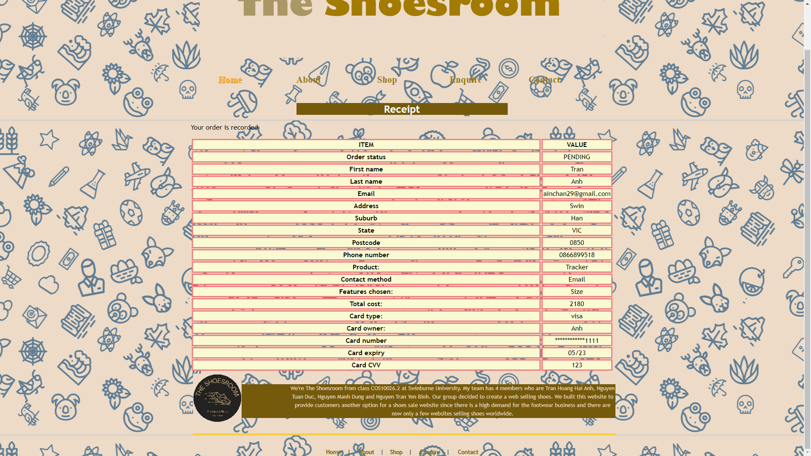

On top right of our website, there are 2 new features added also which is for login our manager account or create a new one.





Once logged in the manager page, the user can sort all information from order as they wish like name, order status, etc.



Users can also update the status of the order to a new one or delete the order as wished. We also add enhancements which are required from the assignment so we can show our best seller, which customer paid us the most, average income per order and show how many orders are there in each status.



***My contribution***

Me and Dung have done mainly the payment and process order including fix order and receipt page.

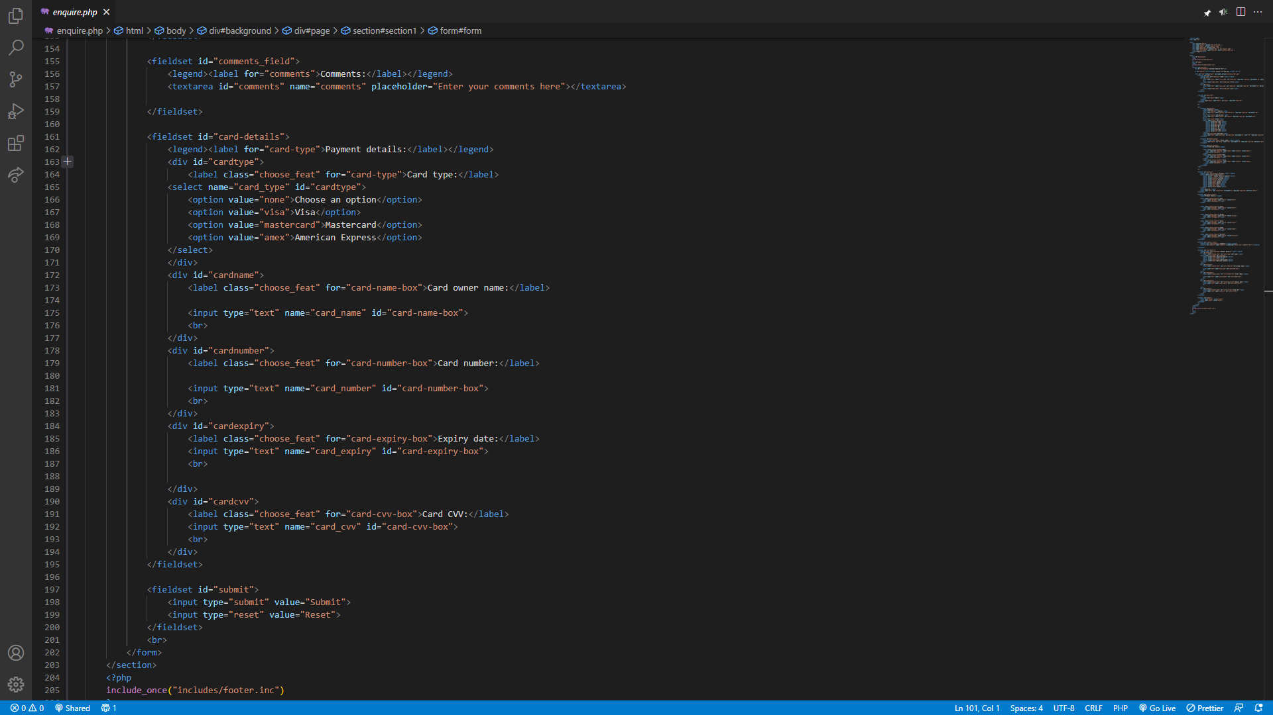

We have extended the payment page so the user can enter their credit card information to pay online.

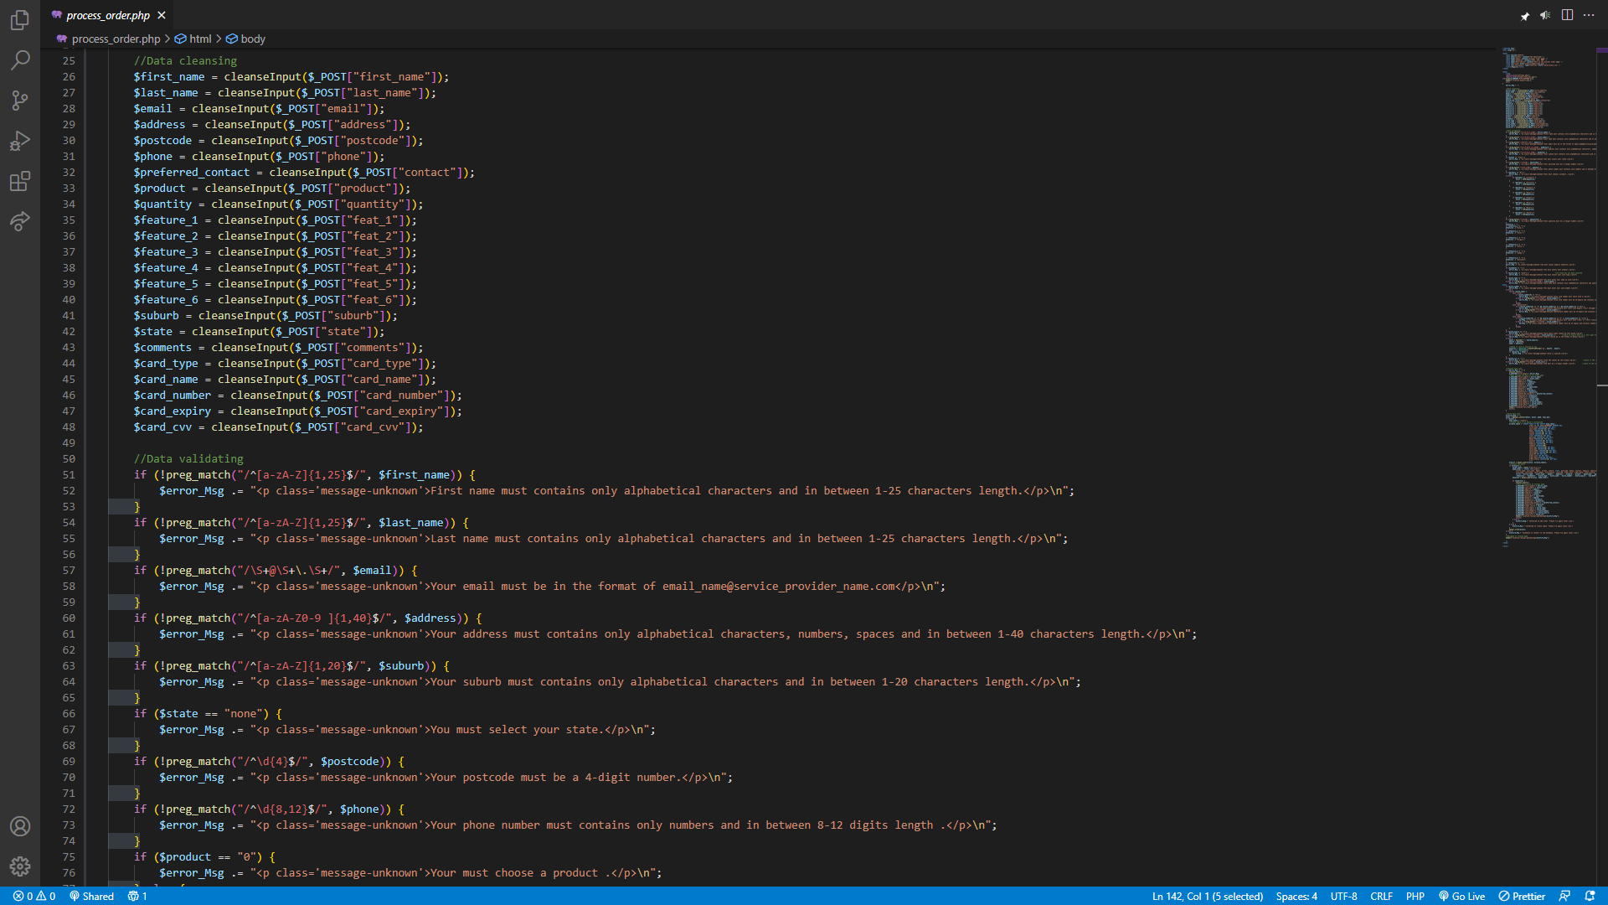

These are variables to take data from the enquire page to process, we will show a message when the pattern isn’t in the correct format as required.

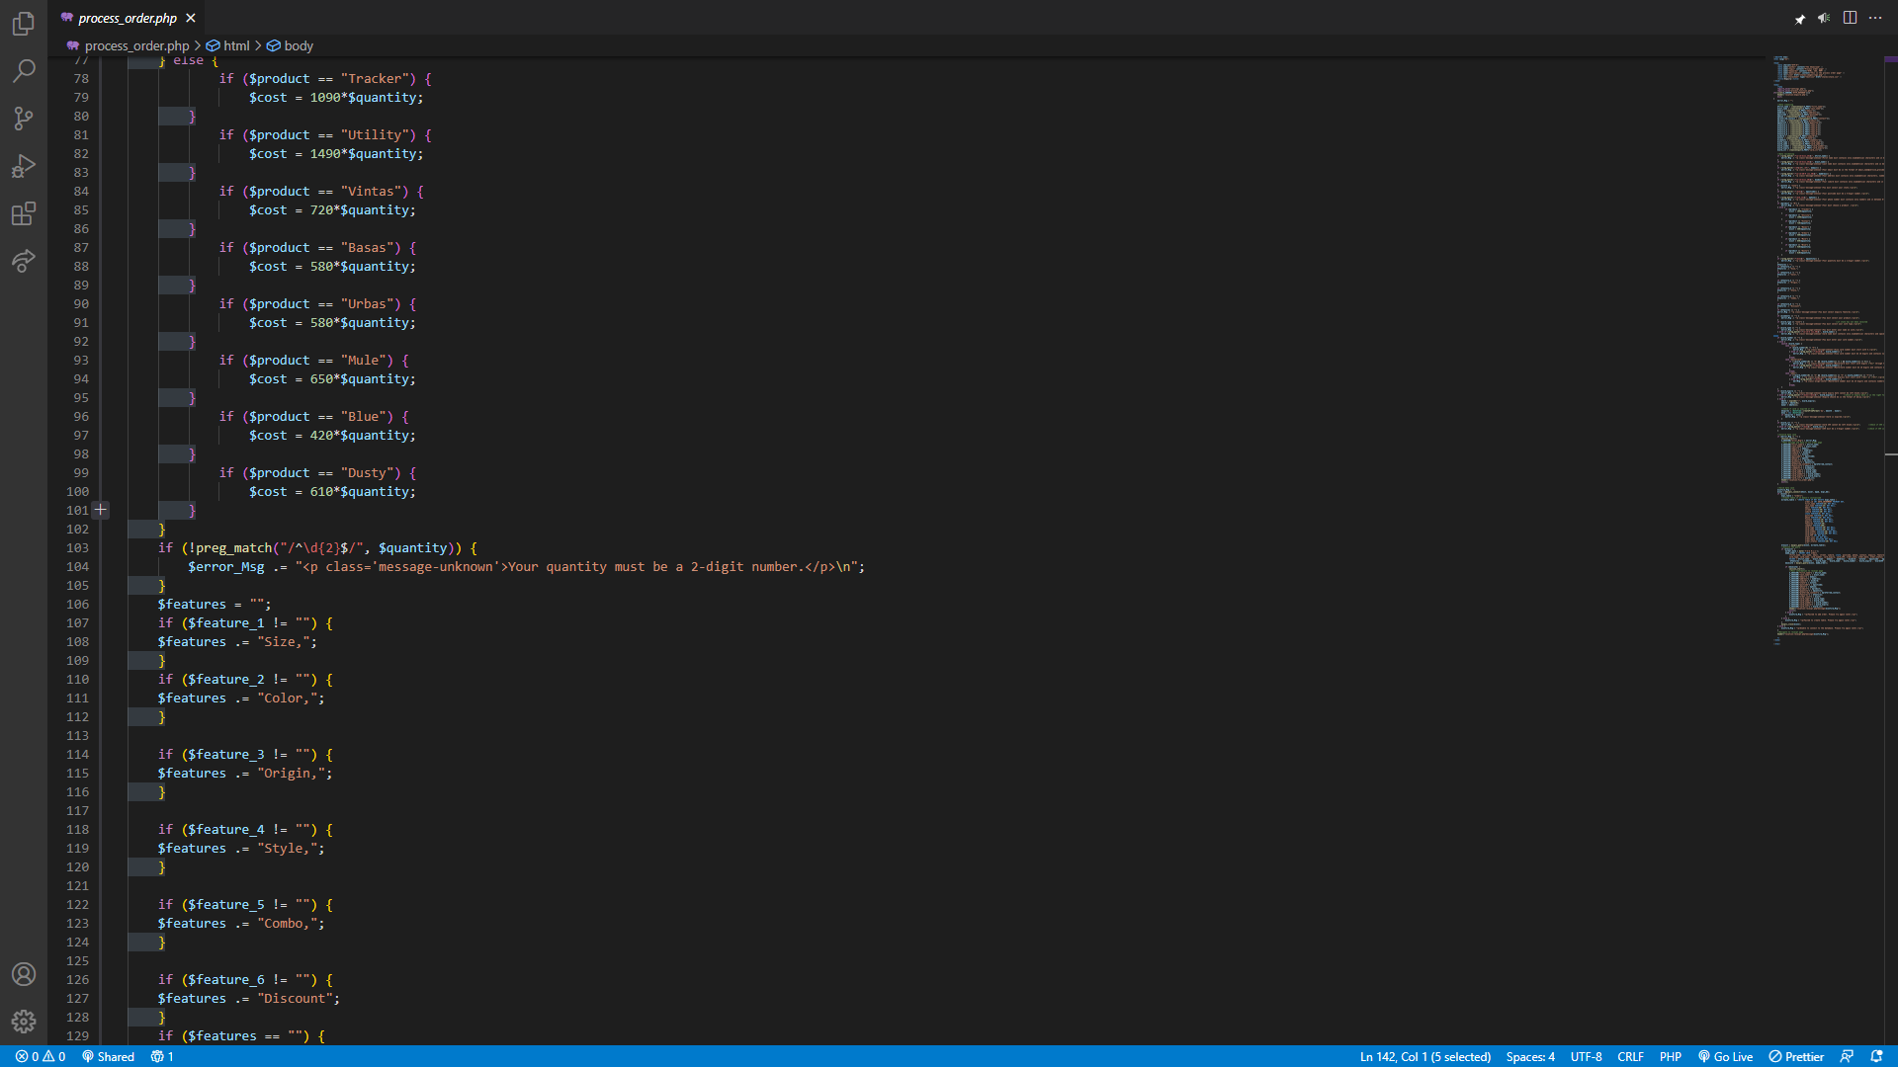

Price multiplied with quantity to get the final cost which the user has to pay.

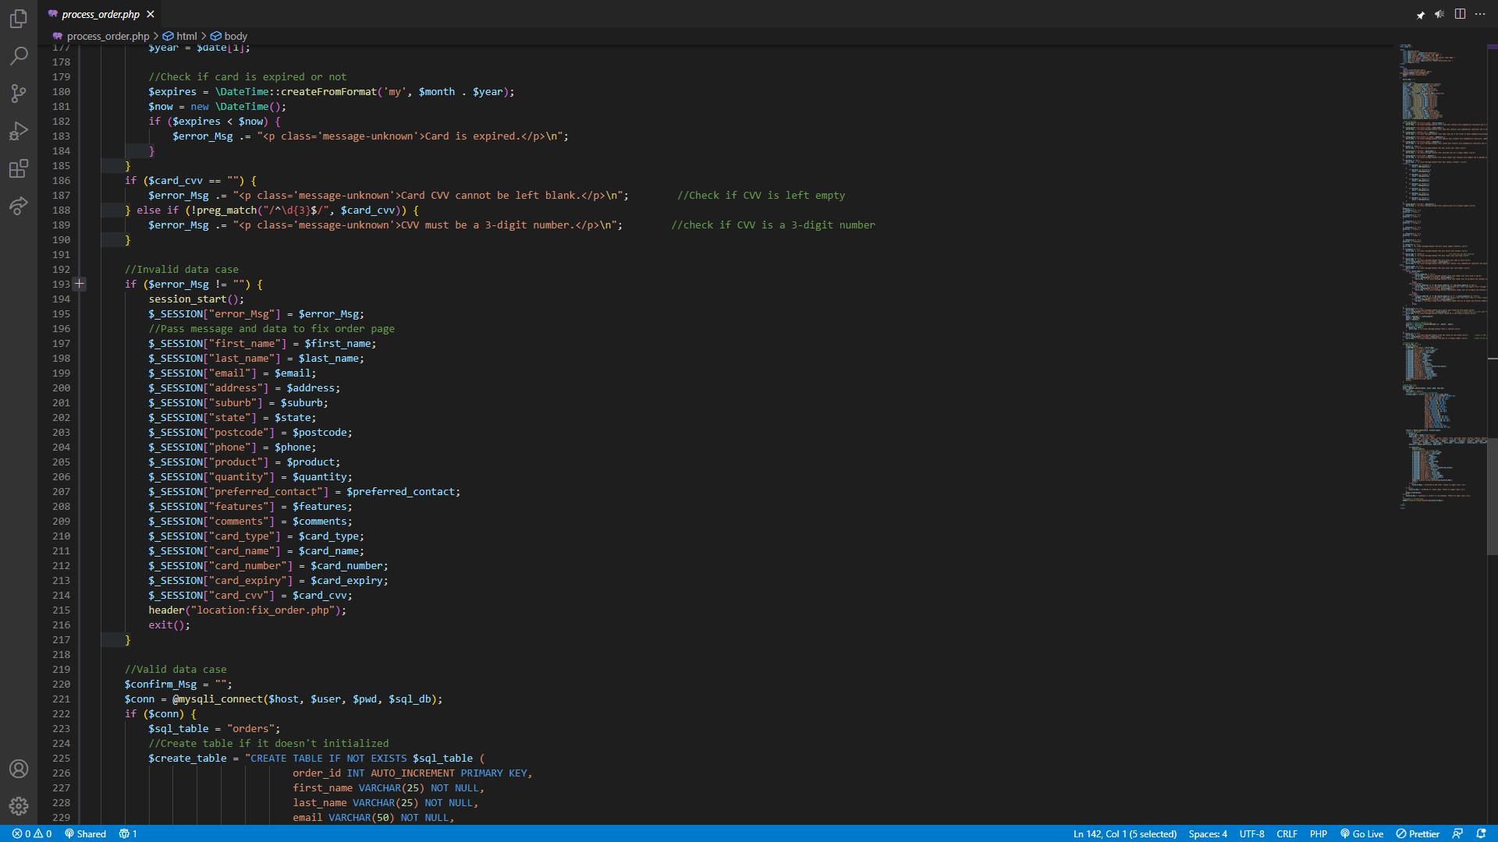

We take the current time date to check whenever the card has expired or not.

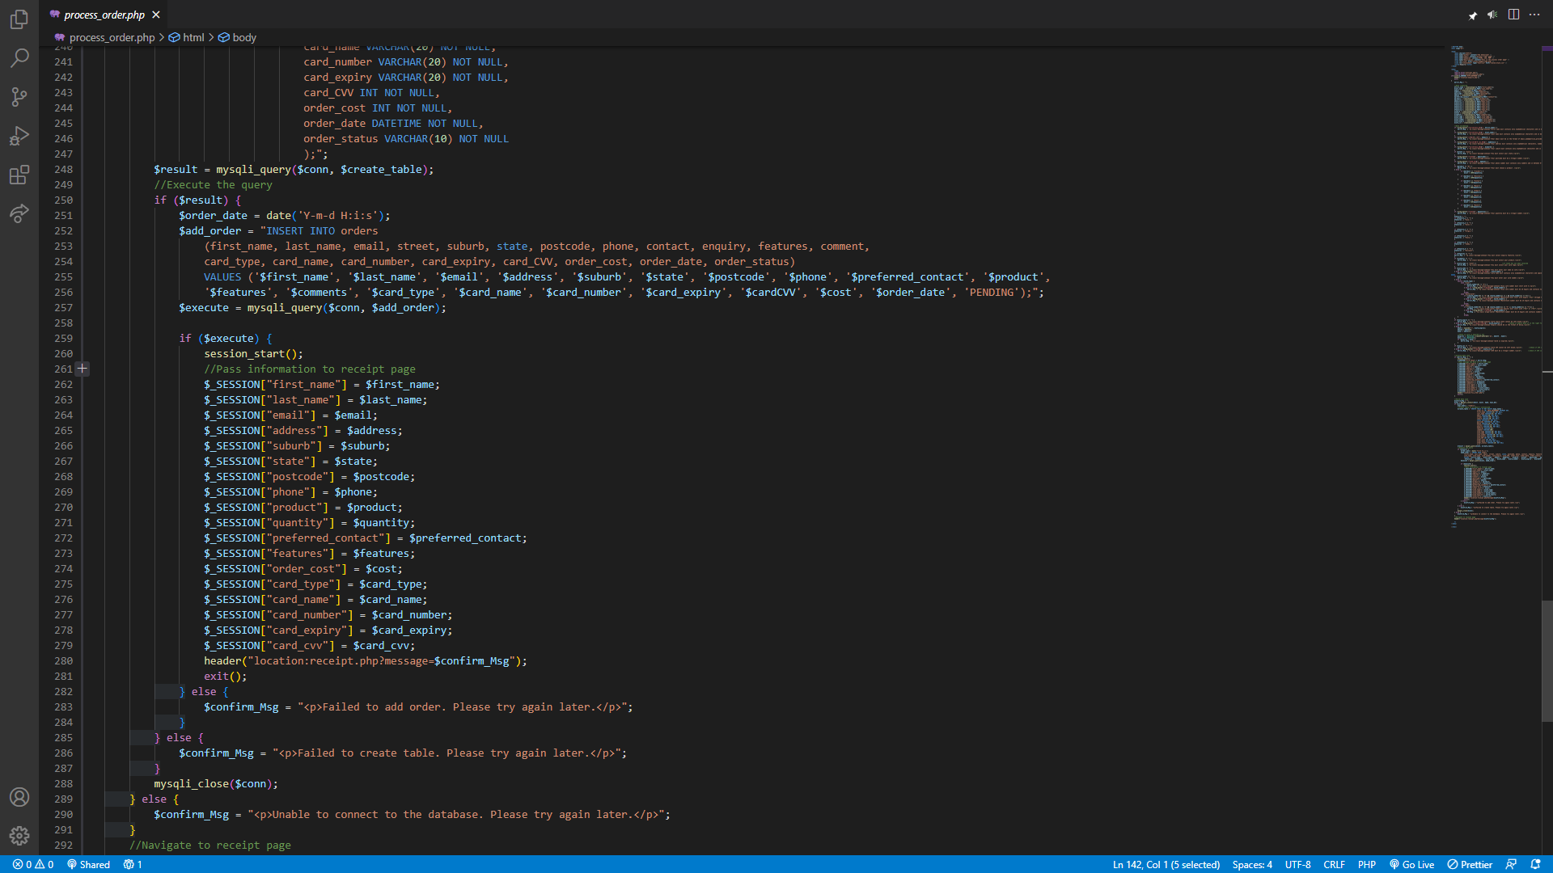

In the end we pass the information to the receipt page.

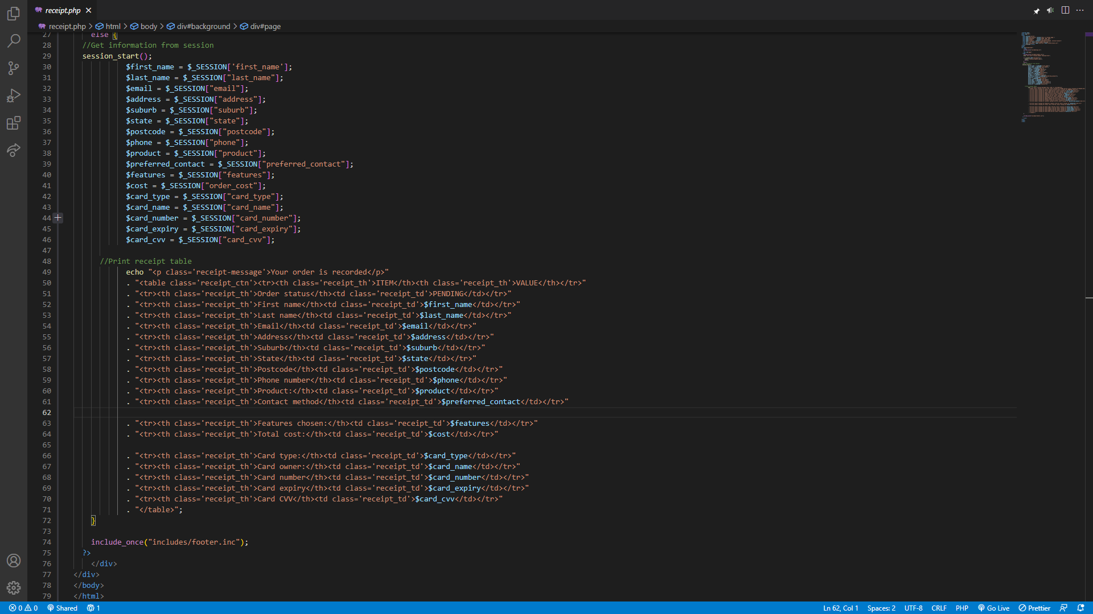

This is where we display our receipt in a html table format for ease to check the overall information.

***Reflection and discussion***

1. Reflection

A defined professional purpose is essential for database projects. Depending on the organization's demands, this goal can entail building a centralized system for storing and managing data, enhancing an existing database's performance, or building a database from the ground up. It is crucial to comprehend the project's goals, purpose, and relationship to the larger corporate plan. The team may remain inspired, engaged, and focused on completing the project goals if they have a clear professional purpose.

Any project, especially one involving databases, requires collaboration. Multiple stakeholders, such as data analysts, developers, and database administrators, are frequently involved in database projects. The roles and duties of each team member should be understood clearly, as well as how their efforts affect the outcome of the project. For the project to move forward smoothly and that everyone is working toward the same objective, effective teamwork and communication are essential.

In every project, good communication is essential, but it might be especially crucial in database projects. To keep everyone informed and to guarantee that any problems or obstacles are quickly resolved, the team must communicate openly and often. Regular team meetings, detailed documentation of the project's needs and goals, and accessible feedback and discussion channels may all contribute to effective communication. Effective communication with stakeholders outside the project team, such as corporate executives and end users, is also crucial to ensuring that the aims and objectives of the project are achieved.

1. Discussion on security

Today, a key concern in online development is web security. When creating online applications, web developers need to be aware of a number of security risks, such as Cross-Site Scripting (XSS) attacks, SQL Injection attacks, Cross-Site Request Forgery (CSRF) attacks, Session hijacking, and Clickjacking. Web developers must adopt secure coding techniques, put in place secure authentication and authorisation procedures, protect data in transit and at rest, and often update and patch software to fix known vulnerabilities in order to stop these attacks. Web developers may secure user information and guarantee the reliability of web-based services by putting these security guidelines into practice.

***Conclusion***

Finally, this report has demonstrated the characteristics and operations of our website, including the login and order processing, the management page, and the upgrades demanded by the assignment. The need of having a clear professional objective, productive cooperation, and communication for database initiatives was also covered in the research. Additionally, the research emphasized how important online security is and how web developers must utilize secure coding practices to safeguard user information and guarantee the dependability of web-based services. We were able to learn a lot about web development and teamwork via this project, which will be helpful for our future work.